Proforma for Applying for financial support to participate in the International Tsunami Symposium (ITS) – 2025 (ITS-2025)
For International / National Early Career Professionals / Research Scholars / Retired Scientists
Last Date: On or Before September 25, 2025
Note:
- Limited in-kind support in partial or full is available only for the international / national early career professionals / research scholars / Retired Scientists.
- The application for in-kind support to participate in International Tsunami Symposium (ITS)-2025 should be recommended/endorsed by the applicant Head of the Organization / Research Supervisor and sent to its2025@incois.gov.in with subject as “Request for In-Kind Support for ITS 2025”.
- The proposed in-kind support covers only Waiver of Registration Fees, Basic accommodation / Hostel facility within INCOIS Campus, Food (Breakfast, Tea/coffee, Lunch and Dinner).
- The In-kind support is only available to the participant, and any accompanying persons need to bear the costs towards registration fees, accommodation and food costs.
- The details on the accommodation facilities available are provided at Annexure 1. The accommodation will be on first come and first serve basis as the rooms available at INCOIS are limited.
- No financial support will be provided to any of the applicant.
- The individual need to take care of the costs involved towards their Air tickets, local conveyances, visa, etc.
Personal Information
 | Name of the Applicant | :
 | Designation | :
 | Affiliation | :
 | Contact address | :
 | Registered Email | :
Scientific Credential
 | Scientific area of active research | :
 | Justification for the support  (Not exceeding 200 words) | :
Conference Participation Information
 | Abstract title | :
 | Abstract submission number | :
 | Technical Session  (Select appropriate session) | : | Choose the Technical Session
 | Mode of presentation  (Select appropriate mode) | : | Choose the mode of presentation
Travel Particulars
 | Traveling from  (Mention City and country name) | :
 | Date of landing at Hyderabad (India) | : | Click or tap to enter a date.
 | Date of start of the return journey from Hyderabad (India) | : | Click or tap to enter a date.
Support Sought:
 | In-kind support applied for  (Select appropriate option) | : | ☐ Registration fee Waiver  ☐ Accommodation at INCOIS Guest House ☐ Food  ☐ Airport Pick up and Drop off
 | Registration Details | : | All the supported applicants need to fill the registration form until the payment screen. Once completed, please email us at its2025@incois.gov.in along with this form. The fee waive off will be done by us and intimated to the successful applicant.
I also accept the terms and conditions mentioned below and noted the extent of support provided to me for participating in the above meeting.
Terms and Conditions:
- Beneficiary agrees to acknowledge INCOIS and ITCOocean
- Beneficiary agrees to submit a copy of their return air ticket, passport and visa, which is mandatory to stay in INCOIS GHs
- Beneficiary agrees to provide the receipt for registration fees / registration confirmation
- Beneficiary agrees to provide any other supporting documents necessary for facilitating the support
Date:
Place
----------------------------------------
(Signature of the applicant)
----------------------------------------------------------------------------------------------------------------

Recommendation / Endorsement by the applicant’s Head of the Organization / Research Supervisor (applicable to early career professionals / research scholars):
It is recommended to provide in-kind support of to Dr / Mr / Ms _________________________________________________________ for participating in the International Tsunami Symposium 2025 (ITS-2025) at INCOIS, Hyderabad, India during November 12-14, 2025.
Date:
Place
----------------------------------------
(Head of the Organization / Research Supervisor with stamp and seal)
----------------------------------------------------------------------------------------------------------------

Annexure 1
Details of INCOIS Guest House Facilities
There are two on-campus guest houses that are built on 60-acres of greenery and co-located with the offices of INCOIS and ITCOocean. Being run by a scientific establishment for students and trainers, the guest house facilities and services cannot be compared with commercial establishments such as hotels. Instead, the guest houses endeavor to offer a safe, clean and homely environment for long stays, with ample opportunities to network during and after the working hours.
There are 78 rooms with different configurations (Suites, Married Accommodation, Double Rooms) that are used to host trainers and trainees of various training programmes as well as interns and research fellows of INCOIS. All guest rooms are air-conditioned and have 1 Queen Bed or 2 Single Beds. Every room has an attached Western Toilet & Shower, Television, Wi-Fi connectivity, study table, wardrobe and an electric kettle. Potable drinking water is available at the guest houses through dispensers which participants are welcome to use.
Rooms and toilets will be cleaned, and linen will be changed twice-a-week. Guests intending to avail this service need to deposit the room key at the reception and inform the attendant. Common Laundry machines are available in the guest house for use by the guests. The guest house also has entertainment facilities such as common TV room, indoor badminton court, table tennis and a gymnasium for use by the guest.
Food for the guests will be prepared in the on-campus kitchen and served in the common dining room of the guest house. While it may be noted that the general style of cooking is Indian cuisine. Alcohol will not be served in the INCOIS guest house. If participants need a wider choice of food, they have option of using several restaurants available outside INCOIS campus or through food delivery Apps on a self-funded basis.
INCOIS will keep a car available at the guest house for use by the participants, should there be a need to visit the city for medical and other supplies and emergency purpose. An attendant will be available at the guest house reception on a 24 x 7 basis to cater to any requests from the guests.
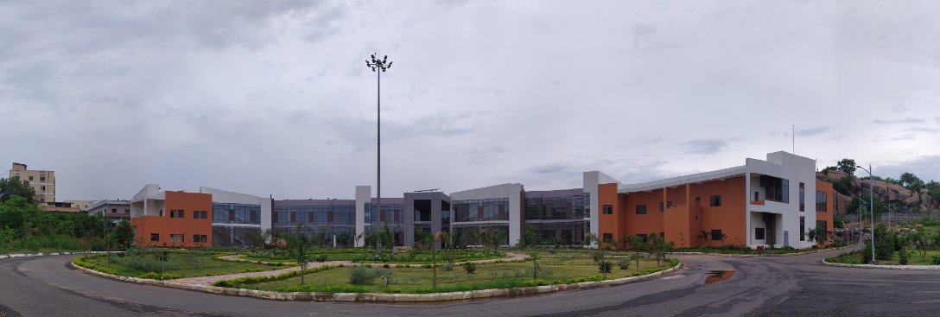
ITCOocean Training Facilities
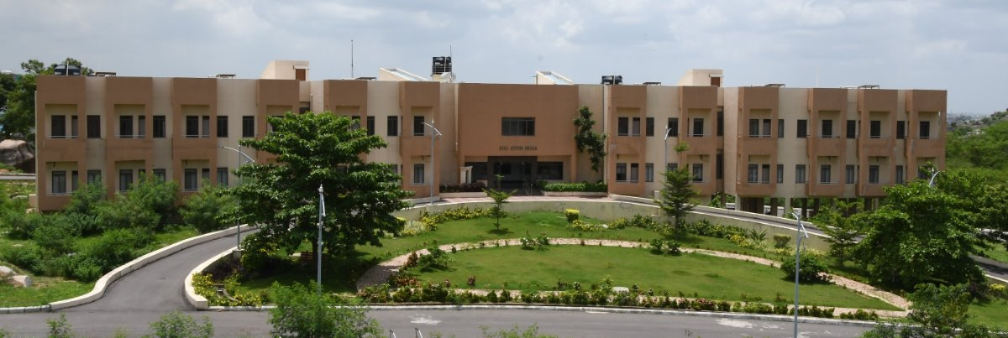
ITCOocean Guest House
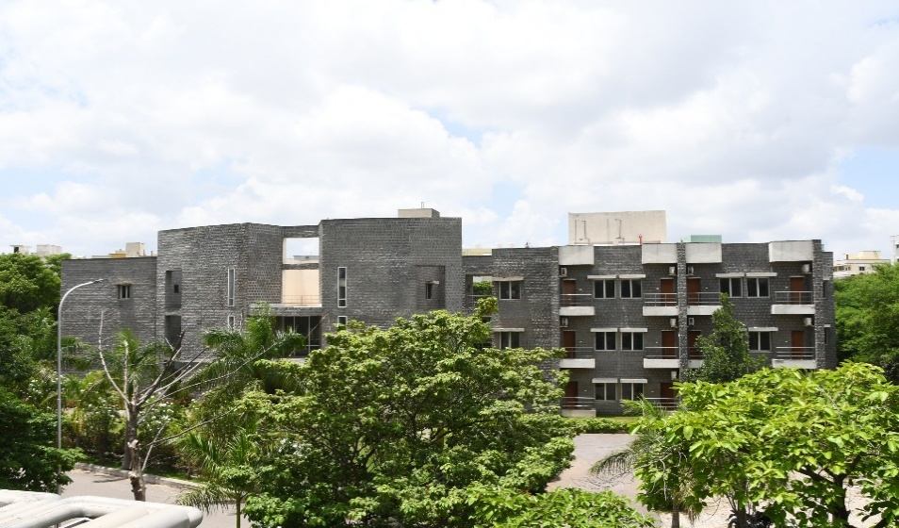
INCOIS Guest House
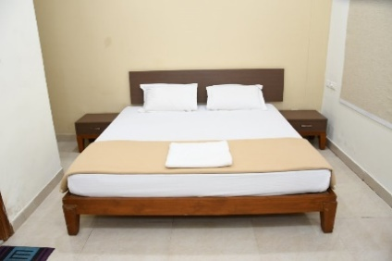  Queen Bed | 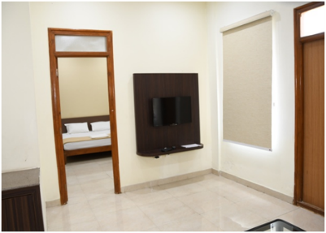  Television | 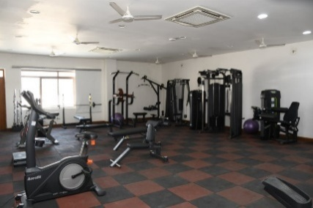  Gymnasium
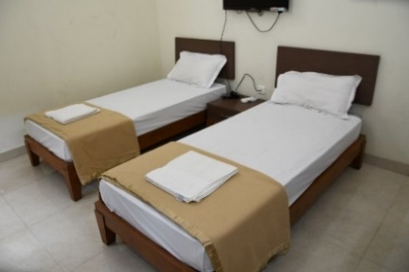Single Beds | 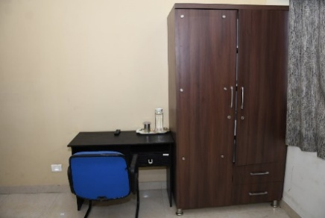  Study Table and Wardrobe | 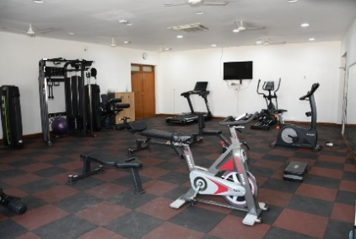  Gymnasium
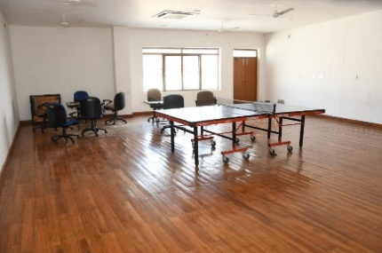  Table Tennis facility | 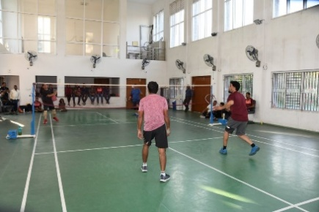  Badminton Facility | 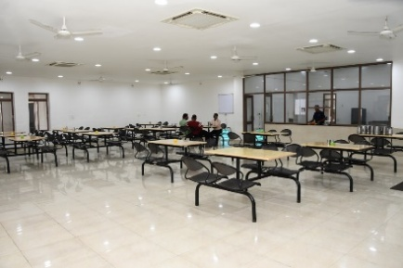  Common dining area

